The most important layers of the osi model are the network or transport layer.
Ipv4=32 bit
Ipv6=128 bit
What is Fragmentation (in Networking)?
Fragmentation is the process of breaking a large packet into smaller pieces so it can be transmitted over a network that has a maximum transmission unit (MTU) smaller than the original packet size.

MTU is the largest size of a packet (in bytes) that can be sent in one piece over a network.

The ip header contain the :
Source address
Destination address
Time to live
Type of service : determine the priority of each packet.
Protocol

Ip 4 header:
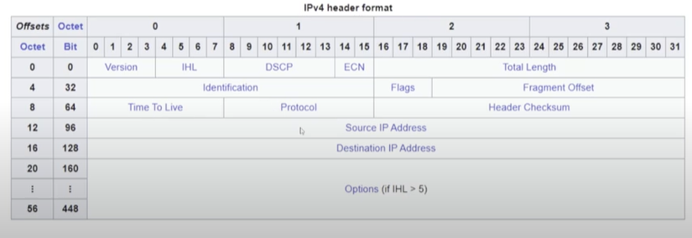
The 32 mean in the second coloumn means this row start from 32 bit and so on for all the rows.
A DMZ is a buffer zone between your internal (trusted) network and the external (untrusted) Internet.
It is used to securely expose public-facing services (like web servers or mail servers) without risking your internal network.
🔐 Example Use Case:
- Your company hosts a website (web.example.com)
- The web server is placed in the DMZ
- If attackers break into it, they cannot reach internal HR or finance systems, because it's isolated

[ INTERNET ]
|
[ External Firewall Interface ]
|
+---------------------+
| FIREWALL |
+---------------------+
| |
[DMZ Interface] [Internal Interface]
| |
+----------------+ +-----------------+
| Web Server | | Internal Network|
| FTP Server | | (PCs, DBs, etc.)|
| Mail Server | +-----------------+
+----------------+

The practical demonstration of the layer are:
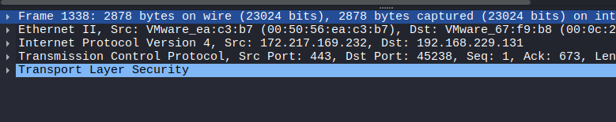
These are the layer
Physical
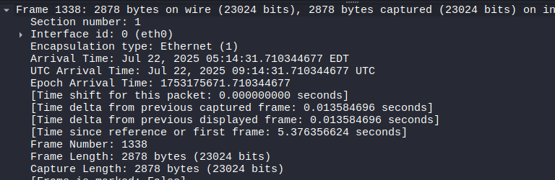
Their all at the physical level.
Datalink
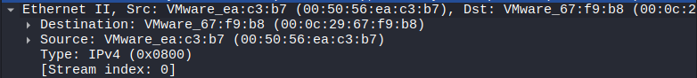
As the datalink layer deals with the physical address so it contain the mac address.
Network
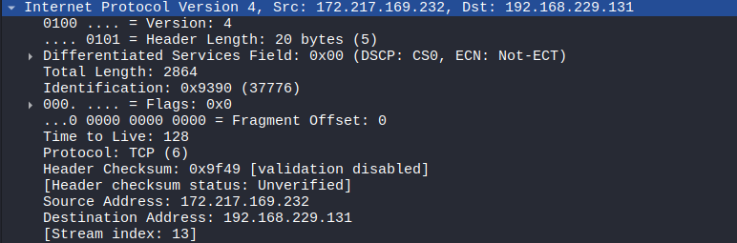
All the thing discussed in the above header photo are shown here.

Transport
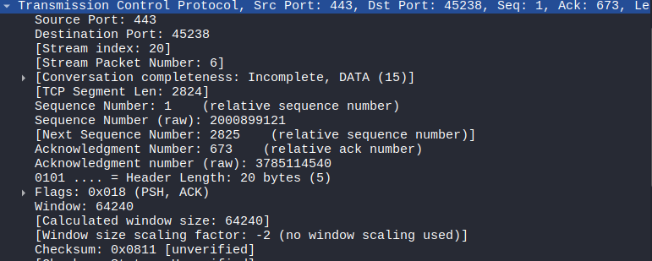
Ports are mentioned in the transport layer.

And all of them contain the data .

